

**Assignment 2: IT Technologies: ROBOTS**

# 

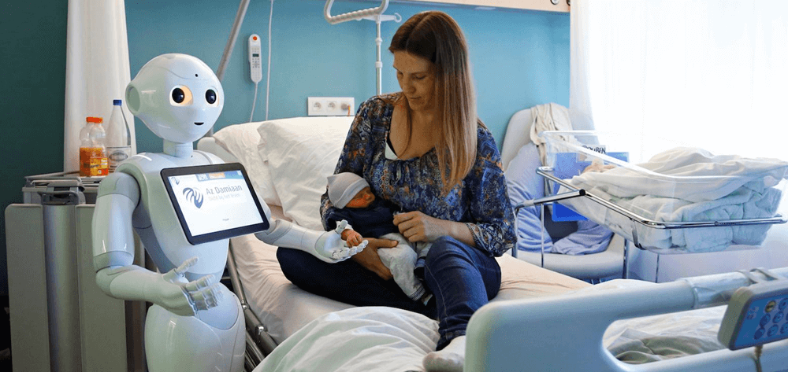

**Course code and name:** COSC2083 Intro to IT

**Student name- ID**: Nguyen Phuc Loi- s3916890

**Lecturer**: Nguyen Minh Long

**Table of Contents**

***I.*** ***What does it do? 3***

**1.** **What is the state of the art of this technology? 3**

**2.** **What can be done now? 3**

**3.** **What is likely to be done soon (say in the next 3 years)? 3**

**4.** **What technological or other developments make this possible? 4**

***II.*** ***What is the likely impact? 6***

**1.** **What is the potential impact of this development? 6**

**2.** **Which people will be most affected and how? 7**

**3.** **Will this create, replace or make redundant any current jobs or technologies? 7**

***III.*** ***How will this affect you? 9***

**1.** **In your daily life, how will this affect you? 9**

**2.** **What will be different for you? 9**

**3.** **How might this affect members of your family or your friends? 9**

***IV.*** ***Reference 10***

# What does it do?

## What is the state of the art of this technology?

In our fast-changing world, as the quality of life in old age has become a prevalent topic, the concern for a healthy and happy existence for seniors has a growing tendency. Furthermore, the growing interest in health has motivated industrial enterprises to concentrate on healthcare technologies development. One of the most pressing concerns in the robotics area is healthcare robot technology, and many enterprises and institutes have taken effort to create it.

## What can be done now?

Furthermore, Robotics utilized in patient monitoring/evaluation, medical supply delivery, and aiding healthcare personnel in unique capacities [4][5][6].

## What is likely to be done soon (say in the next 3 years)?

*Intel* is exploring the next generation of robotics solutions in conjunction with technology vendors and researchers. As a case in point, *Intel Laboratories China* is partnering with the *Suzhou Collaborative Innovation Medical Robot Research Institute* to set up a medical robotics incubator [2]. *Intel* is even supporting the discovery of new applications for AI and IoT technologies in the sphere of medical robotics by providing technical and research assistance. These donations will help to fund ongoing innovations that will boost automation, improve efficiencies, and tackle some of the most pressing healthcare issues. [2]

## What technological or other developments make this possible?

Specifically, the healthcare robot must possess specific capabilities that enable it to assist a person emotionally and/or physically. However, there is no standard interface module for healthcare robot platforms, and there are only a few robots with healthcare capabilities. As a result, creating a common interface technology and applying it to robot platforms might pave the way for the creation of a technology that can improve human physical and mental health.

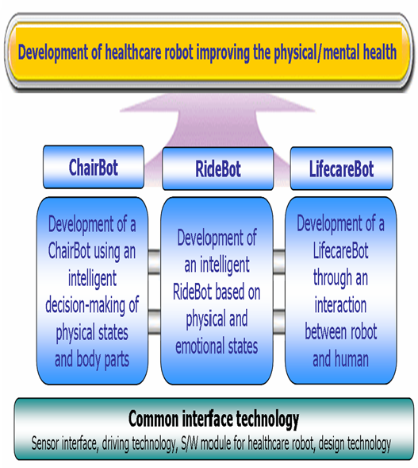

The comprehensive evolution of a healthcare robot technology is demonstrated in Figure 1. The development of a common interface technology and its application to a robot platform can pave the way for the creation of technologies that can improve human physical and mental health.

Lastly, there are three sorts of robot platforms in the study on a healthcare service robot platform consist of ChairBot for relaxation, RideBot for exercise, and LifecareBot for human emotions. Each robot platform comprises common healthcare interface modules and may give specific intelligent services depending on their own goals. Finally, the intelligent healthcare robot is intended to spur the development of a new field and a new product. The following that is the structure of the healthcare robot technologies system in the Figure 2

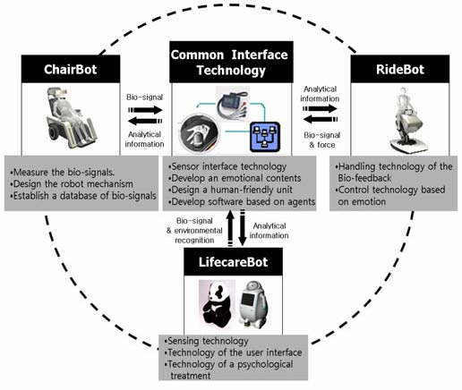

# What is the likely impact?

## What is the potential impact of this development?

Robots in medicine help by relieving medical personnel from routine tasks which is likely to take their time away from more pressing responsibilities, and by making medical procedures safer and less costly for patients, especially in this Covid-19 time.[3]

## Which people will be most affected and how?

In the United States and across the globe, there is a well-documented scarcity of nurses and direct-care workers, which is predicted to worsen as the older adult population rises and prepares for retirement. Aiken et al [10] found that each extra patient per nurse was linked to a 7% increase in patient mortality and a 23% increase in nurse burnout. As a result, research implies that reducing the patient-dependence-nurse ratio would result in fewer missed patient care [9]. As a result, robotics may be able to aid nurses in doing their regular chores, allowing them to deliver better health care. [10]

Robotic solutions in healthcare could assist individual professionals in their difficult task and to address impending staff shortages [8]. The pharmaceutical sector is constantly enhancing the quality of its medicines while also growing the number available. More and more countries are establishing health-care systems. Pharmaceutical items are in high demand all around the world. The pharmaceutical business was mostly unaffected by the recession. As a result, robot investments only marginally declined in 2009. In the medical device market, similar tendencies may be seen. Robotic installations will gain traction in both industries in the next few years [9].

## Will this create, replace or make redundant any current jobs or technologies?

In this era, when it comes to healthcare, we could not forget the Covid-19 pandemics invasion which could have caused a lot of deaths. In healthcare, utilizing robots provides advantages, especially when it comes to limiting in-person interaction during COVID-19 era.

In a research study, 90 percent of patients who were triaged by a Boston Dynamics robot expressed satisfaction with their experience. Therefore, robotics is now being developed for a larger range of medical applications.

Traverso and his colleagues concentrated on innovative techniques to reduce interactions between Covid-19 possibly infected patients and health care staff when the Covid-19 epidemic broke out early last year. In order to accomplish this, they collaborated with Boston Dynamics to develop a mobile robot that could engage with patients while they waited in the emergency room. Sensors on the robots allowed them to monitor vital indications such as skin temperature, breathing rate, pulse rate, and blood oxygen saturation. The robots also have an iPad that allows them to interact with a health care physician through video chat.

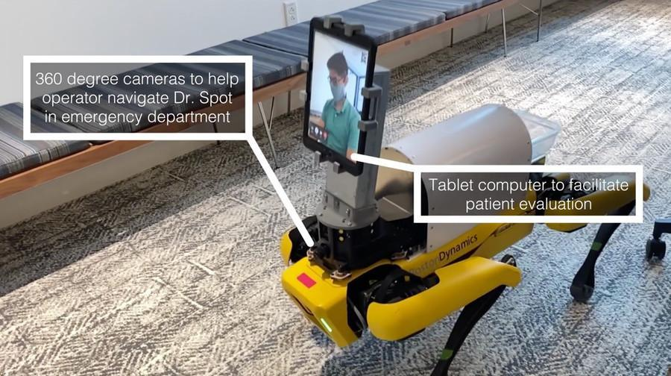

*Figure 3 Ninety percent of patients who were triaged by a Boston Dynamics robot were pleased with their experience. [11]*

This type of robot might help minimize the danger of Covid-19 exposure for healthcare professionals while also conserving the personal protective equipment required for each interaction. [11]

# How will this affect you?

## In your daily life, how will this affect you?

Healthcare robots, in today's fast-paced technology era, are a reflection of technical development and human's mindset, in my opinion. I will be at a disadvantage in comparison to today's young people if I do not make an effort to study and stay up with technological advancements. They are adaptable and broaden-minded, and they produce ideas that outperform those of their predecessors, so I am well aware that I must study to widen my horizon and stay up with this accelerating era.

## What will be different for you?

## Since I updated the state of technology around the world, my life has changed dramatically. Change in life thinking, thinking to catch up with 4.0 technology period trends, so that I may help older people like my parents in technology aspects, because I often stay updated on technology spheres. One interesting aspect is that I frequently deal with a slew of school deadlines, which means that my health suffers as a result. I only wish there was a Healthcare Robot that could look after my health and I am likely to work more effectively.

## How might this affect members of your family or your friends?

People have undertaken a variety of challenges in the Covid-19 period, ranging from unemployment to death. To be honest, I am aware that my parents are nearing old age as well. Thus, with the advancement of Healthcare Robotics technology, my parents will be more at ease with their healthcare demands. The sophisticated service of the robots will reduce the risk of infection from nurses, which is especially sensitive at this time. It is clear that older people, such as our parents, find it difficult to stay up with today's technology trends, therefore I feel this will be a fresh experience for my parents in terms of better understanding the present technological world and mankind's scientific advancement.

# Reference

1/ Contributor, T., 2021. *What are robots and how do they work?* [online] SearchEnterpriseAI, <<https://searchenterpriseai.techtarget.com/definition/robot>> , viewed 16 December 2021.

2/ Intel. 2021. *Robotics in Healthcare: The Future of Medical Care – Intel*. <https://www.intel.com/content/www/us/en/healthcare-it/robotics-in-healthcare.html> viewed 16 December 2021.

3/ Healthcare Administration Degree Programs. 2021. *How are Robots Changing Healthcare? - Healthcare Administration Degree Programs*. <https://www.healthcare-administration-degree.net/faq/how-are-robots-changing-healthcare/> viewed 16 December 2021.

4/ H. H. Lund, “Play for the Elderly-Effect Studies of Playful Technology,” in Human Aspects of IT for the Aged Population. Design for Everyday Life. (LNCS Vol. 9194, pp 500-511, Springer-Verlag, 2015)

5/ H. H. Lund, and J. D. Jessen, “Effects of short-term training of community-dwelling elderly with modular interactive tiles,”, GAMES FOR HEALTH: Research, Development, and Clinical Applications, 3(5), 277-283, 2014.

6/ A.Okamura, M.Mataric, & H.Christensen -Panels. CCC/CRA, Roadmapping for Robotics Workshop: A Research Roadmap for Medical and Healthcare Robotics. Available at: http://www.us-robotics.us/medical-ws.html (2008).

7/ *Positive impact of industrial robots on employment [Internet]. International Federation of Robotics.* 2013. < [http://searchext.abb.com/library/Download.aspx?DocumentID=9AKK105713A4276&LanguageCode=en&DocumentPartId=&Action=Launch](http://searchext.abb.com/library/Download.aspx%3FDocumentID%3D9AKK105713A4276%26LanguageCode%3Den%26DocumentPartId%3D%26Action%3DLaunch).>

8/ *Personalising care and boosting the quality, access and efficiency of healthcare [Internet]* Robotics for Health Care, Intuitive Surgical, Inc; 2013. < <http://www.studymode.com/essays/Robotics-In-Healthcare-Personalizing-Care-And-46056144.html>.>

9/ Robotic nurse assistant [Internet] 2013. Healthcare robotics. <<http://www.hsi.gatech.edu/hrl/project_nurse.shtml>> viewed 17 December 2021 .

10/ Robotic Nurse Assistant. Healthcare robotics; 2013. <<http://www.hsi.gatech.edu/hrl/project_nurse.shtml>.>

11/ Trafton, A., 2021. *The (robotic) doctor will see you now*. World Economic Forum. <https://www.weforum.org/agenda/2021/03/why-robots-can-be-beneficial-in-healthcare/> viewed 16 December 2021.